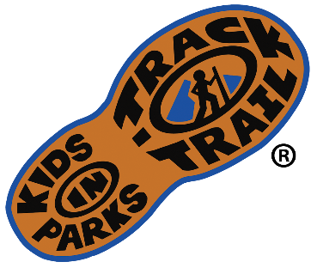
For Immediate Release

Media Contact:
Jason Urroz
Program Director, Kids in Parks
Blue Ridge Parkway Foundation
(866) 308-2773, ext. 384
jurroz@brpfoundation.org
www.kidsinparks.com

Come hike at [Name of Park/Trail/Location] for a special Kids in Parks TRACK Trail adventure on [Date (Ex. April 12th)]

On [Date], come have fun with [Park/Organization/Partner] and Kids in Parks as they celebrate [Holiday/event/etc] at [Park/Trail/Location] near/in [City, State]. A guided hike will begin at [00:00] at [location of start] and then follow the TRACK Trail for a [0.0]-mile walk [around/through/etc. description of trail].

[Insert any further instructions for the event as well as activities that will occur at the event. Ex. Driving and parking instructions, guided hikes]

For over a decade, Kids in Parks has connected kids and families to public lands nationwide through their principal initiative, TRACK Trails. With family-friendly trails for hiking, biking, canoeing, disc golf, and more, over 200 locations exist in the TRACK Trail network, spanning 15 states, Washington, D.C., and the Qualla Boundary. Each TRACK Trail hosts a series of self-guided activity brochures that turn hikes into exciting outdoor experiences. Registered participants can earn free prizes designed to encourage further outings.

To learn more about TRACK Trails visit KidsinParks.com. For directions or more information visit [partner website] or call [partner phone #].

Name of Park/Trail/Location
Street Address
City, State Zip

