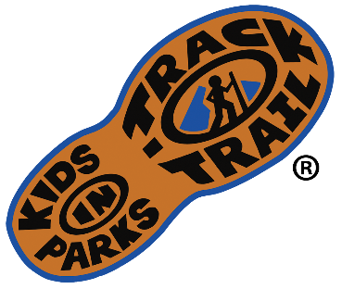
For Immediate Release

Media Contact:
Jason Urroz
Program Director, Kids in Parks
Blue Ridge Parkway Foundation
(866) 308-2773, ext. 384
jurroz@brpfoundation.org
www.kidsinparks.com

[Name of Park/Trail/Location] TRACK Trail Grand Opening on [Date (Ex. April 12th)]
For over a decade, the Kids in Parks program has connected kids and families to public lands nationwide through their principal initiative, TRACK Trails. Each TRACK Trail location is family-friendly and features a series of self-guided activities to turn visits into fun and exciting outdoor experiences. Best of all, participants can earn free prizes in the mail for tracking adventures at kidsinparks.com!

On [Date], Kids in Parks and [Park/Organization/Partner] will celebrate the grand opening of a new TRACK Trail at [Park/Trail/Location] near/in [City, State]. Kids in Parks has over 200 TRACK Trails across 15 states, Washington, D.C., and the Qualla Boundary, comprising a national network of trails. Kids and families can hike, bike, canoe, play disc golf, and more, all while learning about the natural, cultural, or historical resources located at each site. Kids in Parks also operates a complementary parks prescription initiative, TRACK Rx, presently working with over 600 pediatric partners.

Kids in Parks began on the Blue Ridge Parkway, developed by the Blue Ridge Parkway Foundation in partnership with the National Park Service and the Blue Cross Blue Shield of North Carolina Foundation. As the program demonstrated easy implementation and effectiveness in getting children outdoors, Kids in Parks has rapidly expanded to other parks and public lands across the country.

“The network of TRACK Trails we have formed in parks and other outdoor agencies gives kids and families more options to get outdoors. To get ‘unplugged’ and get connected to the resources and special places that make this region so wonderful,” says Jason Urroz, director of Kids in Parks.

[Feel free to insert quotes from partners, or any other desired information about the Park/Trail/Location or the collaborative efforts that went into creating this TRACK Trail]

The grand opening celebration of the [Park/Trail/Location] TRACK Trail will be on [Day of Week, Month Day] at [Time of Event AM/PM]. [Insert any further instructions for the Grand Opening Event as well as activities that will occur at the event. Ex. Driving and parking instructions, guided hikes]

To learn more about TRACK Trails visit KidsinParks.com. For directions or more information visit [partner website] or call [partner phone #].

Name of Park/Trail/Location
Street Address
City, State Zip

